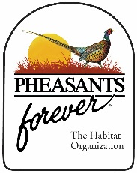***Press Release***

***For Immediate Release***

Allie Rath (319) 330-6015

[arath@pheasantsforever.org](mailto:arath@pheasantsforever.org)

**Managing Prairie with Prescribed Fire to Control Brome**

**February 10, 2022 –**

It’s been up and down with winter weather recently and I’m sure we’re all dreaming of spring! Along with spring comes prescribed fire on native grasslands and CRP (Conservation Reserve Program) fields. Prescribed fire is a great tool we can utilize to manage native prairie/grassland areas. A well-timed fire will invigorate native prairie species and help suppress non-native cool-season grasses and woody vegetation. The normal recommendation is to burn a site on a 3- to 5-year rotation and to split-up your site, if it’s big enough, into at least 2 burn units to maintain cover/refuge for wildlife. When spring is upon us, and prescribed burns start being implemented, let’s remember what role objectives play in when we burn. If you have any non-native cool-season grasses, like brome, creeping into your native CRP field or prairie then you’ll want to pay attention!

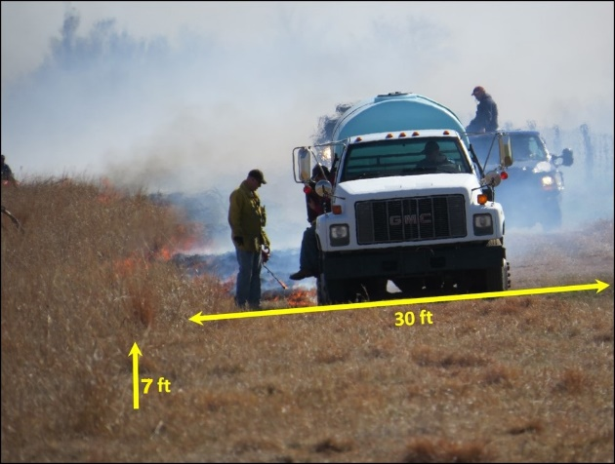First, let’s review the importance of firebreaks. We recommend a minimum of a 20’- to 30’- wide firebreak around your field you intend to burn. Hopefully you mowed your firebreaks last fall. This will help the dead material you cut last fall deteriorate over winter and remaining vegetation green-up faster in the spring. Greener and cleaner is better. If you haven’t mowed your firebreak yet the next best option is a possibility that you would be able to hay your firebreak in early spring which would provide the most effective firebreak, but you will need to check with FSA (Farm Service Agency) first and it will probably require a fee (well spent in my opinion). If you haven’t mowed your firebreak yet the second-best option is to push your burn back a year, so you can mow your firebreaks appropriately this year. If you have CRP, you will want to start this process by requesting an extension for your burn from FSA. If you will still be burning this spring and have not mowed your firebreak yet, I would still encourage mowing a minimum of a 20’- to 30’- wide firebreak this spring (ASAP) before you burn; wider is better. You could try to rake the mowed residue AWAY from the burn unit, so the fire doesn’t sit and smolder (where there’s smoke, there’s fire) near the fire line. Raking it into the burn unit would make someone have to babysit the smoldering areas and create an unsafe situation. If you have to rake it into the burn unit, try to spread out the material as much as possible, not in piles/rows, to prevent as much smoldering as possible. Another option includes mowing and thoroughly disking a firebreak, exposing black soil greatly decreasing the chance of the fire getting out of hand. This option may require reseeding in CRP.

Firebreak using a mowed/hayed method. The wider the better for taller vegetation.

Many landowners conduct burns in ditches in early spring and it gets others pumped up to burn. However, if you have non-native grasses you’re trying to reduce, you must resist the urge and remember your objectives. Brome could be coming from a road ditch, waterway, neighbors or from an old CRP you previously had. As a rhizomatous perennial, brome can outcompete natives. Controlling/reducing brome will help maintain and/or increase your native species and also help keep you in compliance with your CRP contract. The best time to burn your native CRP or prairie to reduce brome is when the brome’s growing point is up out of the ground and susceptible to damage. Most of the time this happens in late spring (~mid-April - mid-May) but this plant stage can fluctuate each spring, depending on temperature and moisture. Finding the perfect date to burn to reduce brome can be difficult but if you can wait until there are several leaves on the brome stem then you have a better chance of having a better reduction. If you’re in CRP, then you have restrictions on your timeline for burning, too. You will need to get your burn completed before May 15 (the start of the nesting season). There are also logistical factors that make burn-timing difficult too, like physical help (friends or family) or when a hired contractor can get there. But the main take-a-way is to try to wait about as late as possible in the mid-to-late-April – May 14th time frame. This late spring burn will also help put some hurt on volunteer woody species and stimulate your native grasses. Once you have your brome under control you will want to change up the season in which you burn to stimulate different native grass and wildflower species.

Another great option, if you are having issues with non-native grasses and you have wildflowers, which you will want to keep, is moving the timing of the burn to early spring (right after snow leaves and is dry) and add a follow-up grass-selective herbicide spray. This will reduce your non-native grasses but leave your wildflowers alone. This option could also be used if you just don’t have much time during the late-spring time frame. But make sure you follow-up with a grass-selective spray. An early spring burn by itself will only stimulate the non-native grasses you are trying to get rid of.

Fire is an important tool used to maintain and invigorate native prairie. Conducting them safely and effectively will help everyone see the benefits to prescribed burning. Always contact the county dispatch to let them know before you burn and where you are burning. Additionally, it is courteous to call dispatch back when the burn is completed to let them know it is done. Always know the weather parameters you should be burning in and know what the weather is going to do the day you burn and the day after. Much of these questions can be answered if you have a prescribed burn plan. Here’s a link to the NRCS burn plan template <https://efotg.sc.egov.usda.gov/references/public/IA/Prescribed_Burning_338_JS_2008_09.pdf>.

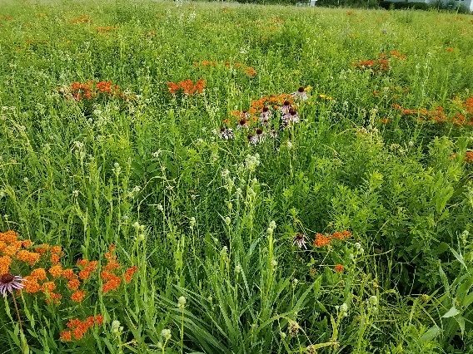If you have any questions about how to conduct a prescribed burn, when you should burn, need a list of contractors, or to line up a site visit, please contact your local Farm Bill Wildlife Biologist, DNR biologist, or USDA service center.

Field of native grasses and wildflowers that were stimulated from a late spring burn.